**SDS-01**

SOFTWARE DESIGN DESCRIPTION

**On Time!**

for:

RPLGDC Laboratory

Prepared by: 1301192218

Prepared by:

|  |  |  |
| --- | --- | --- |
| Akmal Raafid | 1301192218 | Project Leader |
| Ditya Athallah | 1301194095 | Programer |
| Risyad Faisal Hadi | 1301194232 | Programer |
| Nur Ahsar Setiyowen | 1301180506 | Designer |

Bachelor of Informatics – Faculty of Informatics (School of Computing)

Telkom University

Jalan Telekomunikasi Terusan Buah Batu, Bandung

Indonesia

|  |  |  |  |  |
| --- | --- | --- | --- | --- |
|  | **Informatics Bachelor-Faculty of Informatics** | Document Number | | Pages |
| SDS-01 | |  |
| Revision |  | Date: |

Change List

|  |  |
| --- | --- |
| Revision | Description |
| A | Sequence diagram (the should be same with use case scenario) |
| B | References should refer to SKPL |
| C | Component diagram |
| D | Document coverage, write based our topic |
| E | Add testing section |
| F |  |
| G |  |

|  |  |  |  |  |  |  |  |  |
| --- | --- | --- | --- | --- | --- | --- | --- | --- |
| INDEX  Date | - | A | B | C | D | E | F | G |
|  |  |  |  |  |  |  |  |  |
|  |  |  |  |  |  |  |  |  |
|  |  |  |  |  |  |  |  |  |

Pages Changes List

|  |  |  |  |
| --- | --- | --- | --- |
| Page | Revision | Page | Revision |
| 8  11-31  8  10 | Fix the document coverage based on our topic  Sequence diagram change match with use case scenario  Make reference from our SKPL  Fix the component diagram |  |  |

# Table of Contents

Revision 1

Page Revision 2

Table of Contents 3

1. Introduction 5
   1. Document Purpose 5
   2. Document Conventions 5
   3. Product Scope 5
   4. Reference 6
2. Overall Description 6
   1. Product Perspective 6
   2. Product Functionality 8
   3. Users and Characteristic 9
   4. Operating Environment 9
   5. Planning Limitations and Implementation 9
   6. Users Documentation 9
   7. Assumption and Dependencies 9
3. External Interface Requirements 10
   1. User Interface 10
   2. Hardware Interface 10
   3. Software Interface 10
   4. Communication Interface 10
4. System Features 11
   1. Reminder 11
      1. Description: 11
      2. Trigger: 11
      3. Input: 11
      4. Output: 11
      5. Main Scenario: 11
         1. pre-condition: 11
         2. post-condition: 11
         3. Steps: 11
      6. Exceptional Scenario 1: 11
      7. pre-condition: 11
         1. Post-Condition: 12
         2. Steps: 12
   2. Ringtone Alarm 12
      1. Description: 12
      2. Trigger: 12
      3. Input: 12
      4. Output: 12
      5. Main scenario: 12
         1. Pre-condition: 12
         2. Post-condition: 12
         3. Steps: 13
      6. Exceptional Scenario 1: 13
         1. pre-condition: 13
         2. post-condition: 13
         3. steps: 13
   3. Connect to Other App 13
      1. Description: 13
      2. Trigger: 13
      3. Input: 13
      4. Output: 13
      5. Main Scenario: 13
         1. pre-condition**:** 14
         2. post-Condition: 14
         3. steps: 14
      6. Exponential Scenario 1: 14
         1. pre-condition: 14
         2. post-Condition: 14
         3. steps: 14
   4. Theme Changing 14
      1. Description: 14

|  |  |  |
| --- | --- | --- |
|  | 4.4.2 Trigger: | 14 |
|  | 4.4.3 Input: | 14 |
|  | 4.4.4 Output: | 15 |
|  | 4.4.5 Main Scenario: | 15 |
|  | 4.4.5.1 pre-condition: | 15 |
|  | 4.4.5.2 post-Condition: | 15 |
|  | 4.4.5.3 steps: | 15 |
|  | 4.3.6 Exponential Scenario 1: | 15 |
|  | 4.3.6.1 pre-condition: | 15 |
|  | 4.3.6.2 post-Condition: | 15 |
|  | 4.3.6.3 steps: | 15 |
| 5. | Requirements Non-Functional | 16 |
| 5.1 Quality Attribute | | 16 |
| 5.2 Requirements Legal | | **16** |

# Introduction

## Purpose of Writing Document

This document Software Design Description (SDD) is a document that aims to describe in detail the software to be built. This document is used by software developers as a reference for developing software at a later stage.

Users of this document are used by developers of software and stakeholders involved in this system. With the drafting of this SDD document, it is expected that the development of software will be more conceptual and not cause ambiguity during development.

## Document Coverage

The purpose of this document is to present a detailed description of our application called “On

Time!”. It will explain the purpose and features of the system, the interfaces of the system, what the system will do, and the constraints under which the system must operate. This document is intended to be used as a reference for developing the initial version of the On time! application for the development team.

## Definitions and Abbreviations

|  |  |
| --- | --- |
| **ABBREVIATIONS** | **DEFINITIONS** |
| SDD | (Software Design Description) Documents that describe and describe in detail the design of software to be built. |
| SRS | (Software Requirement Specification) is a specification of the software that will be developed. |
| API | (Application Programming Interface) computing interface that defines interactions between multiple software intermediaries. |
| React Native | Framework for developing an app on android, android TV, iOS, macOS, tvOS, Web, Windows and UWP |
| iGracias | Is a website for Telkom university student to check any information about Telkom University |
| JavaScript | Scripting language, which is a language that does not require a compiler to run it, but it is enough with an interpreter |
| DBMS | MySQL for database |
| PHP | PHP (Hypertext Preprocessor) is known as a general-purpose scripting language that can be used to develop dynamic and interactive websites. |

## References

1. Group-4 IF-43-INT.(2022).SRS On Time

## Systematic Discussion

# This SDD document contains a description of the design of the On Time that will be developed based on the SRS document. This SDD document will explain the details of software design so that it can be implemented. This document generally consists of four chapters with the following details:

# 1. Preliminary

# Preliminary contains an explanation of the SDD document which includes the purpose of making this document, the scope of the problem solved by the software developed, the definitions and terms, references and efforts of the document.

1. Global Design Description

# The description of the global design contains the design of the software that will be built including the design of the implementation environment, architectural description, and description of the components.

# Detailed Design

# The detailed design of this document contains the realization of use cases, designing class details, class diagram descriptions, algorithms diagrams, interface design, and designing class persistence representations.

## Document Purpose

The purpose of this document is to present a detailed description of our application called “On Time!”. It will explain the purpose and features of the system, the interfaces of the system, what the system will do, and the constraints under which the system must operate. This document is intended to be used as a reference for developing the initial version of the On time! application for the development team.

## Product Scope

On time! is a reminder app with a mobile application method. It will allow users to set a reminder of an event and will be notified by a ringtone. So, that the users will not miss any event that has been marked in this application.

# Global Design Description

## Product Perspective

Being late is almost considered as a habit for college students, the only way to overcome being late is change of habit. It is not easy to change a habit for a short time, but there is some way to help it by making a weekly schedule, setting an alarm or asking a friend to notify the person for a certain event. Those 3 actions can be done within your mobile devices. There are several applications that can do some of those actions. The application contains a calendar and alarm. by marking a date, time, event description, and notification time. by inputting those requirements, the application will notify the user by popping up a notification on the mobile device.

This product is very similar to any reminder applications, but this product is intended to help *civitas academica* so that the product could be connected to the college website to link the schedule to the app. the product will be available in Android and iOS devices only because most of the people in the world use those devices.

* 1. **Architectural Description**

Architectural Description is the result of a set of practices for representing, communicating, and analyzing a software architecture (also known as architecture rendering) and the application of such practices by work products that represent the software architecture or Product Functionality that will be applied to the software “On Timer” to facilitate developers in developing or implementing this software.

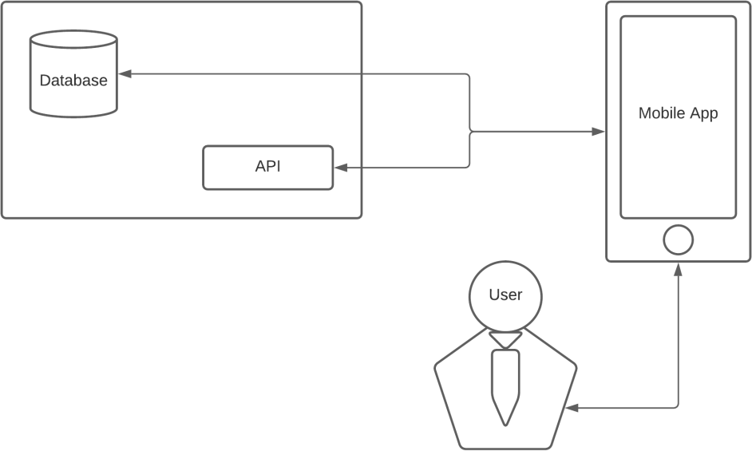

**Figure Architectural Descripton**

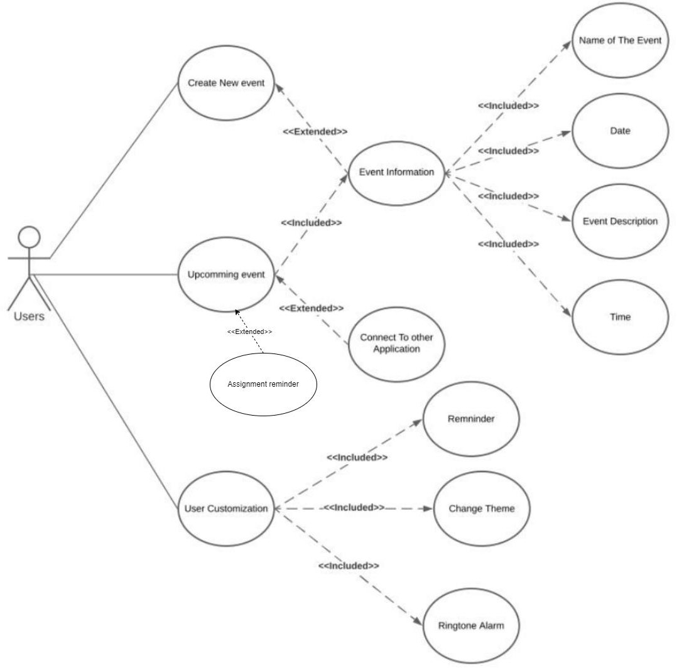**2.3 Product Funcationality**

**Figure Product Functional**

## Component Description

Table 1 Component Description Table

|  |  |  |
| --- | --- | --- |
| **No** | **Component Name** | **Explanation** |
| 1 | On Time | The software that will be developed |
| 2 | User | The one whole used the web |
| 3 | Login | The menu for login so the user can access the features in the application based on each role |
| 4 | Main page | Main menu that user can see everything on it |
| 5 | Create event | Menu to create a new event |
| 6 | See Upcoming Event | Menu to see upcoming event |
| 7 | Customize the web | Menu for user to customize the web |
| 8 | Link to other app | Menu to linked with another app |
| 9 | See Information of the  event | Menu for user to see the detailed information of the  event |

# Detailed Design

## Realization Use Case

### Use Case Create New Event

#### Class Identification

**Table 3 Create New Event Identification Table**

|  |  |  |
| --- | --- | --- |
| No | Design Class Name | Class Type |
| 1. | User | User |
| 2. | Main page | Main page |
| 3. | Create New event | Create New Event |

#### Sequence Diagram

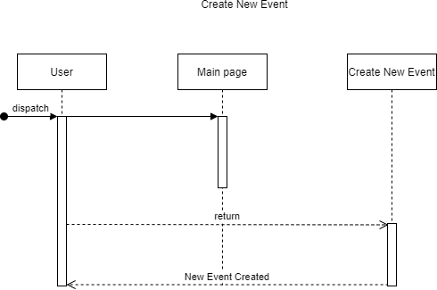Picture 3 Sequence Diagram Create New Event

**Figure Create New Event**

#### Class Diagram

### Use Case Create New Event

#### Class Identification

**Table 3 Create New Event Class Identification Table**

|  |  |  |
| --- | --- | --- |
| No | Design Class Name | Class Type |
| 1. | User | User |
| 2. | Main Page | Main page |
| 3. | Create New event | Create New event |

#### Sequence Diagram

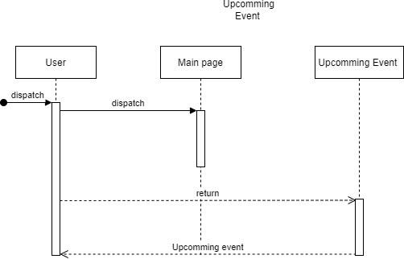Picture 3 Sequence Diagram Upcoming Event

**Figure Upcomming Event**

#### Class Diagram

### Use Case Upcomming

#### Class Identification

**Table 3 User Customization Class Identification Table**

|  |  |  |
| --- | --- | --- |
| No | Design Class Name | Class Type |
| 1. | User | User |
| 2. | Menu Page | Main page |
| 3. | Upcomming Event | Upcomming Event |

#### Sequence Diagram

Picture 3 Sequence Diagram User Customization

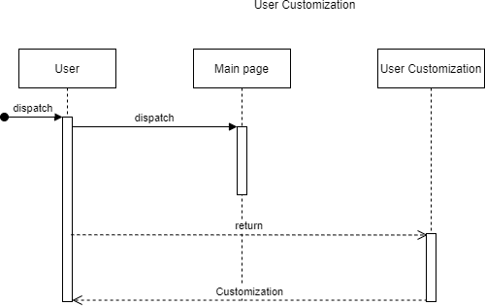

#### Class Diagram

### Use Case User Customization

#### Class Identification

**Table 3 User Customization Class Identification Table**

|  |  |  |
| --- | --- | --- |
| No | Design Class Name | Class Type |
| 1. | User | User |
| 2. | Main Page | Main Page |
| 3. | User Customization | User Customaization |

#### Sequence Diagram

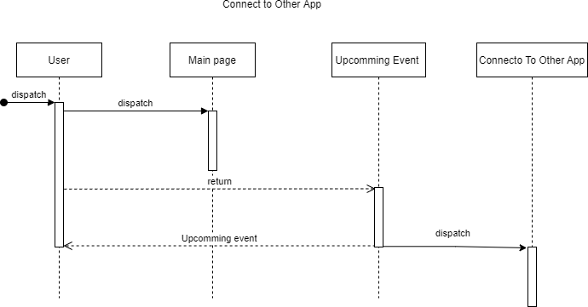Picture 4 Sequence Connect to Other App

**Figure Event Information**

#### Class Diagram

### Connect to Other App

From this use case,the user can connect to other apps. For example LMS so that the timeline on LMS can be displayed and remembered in our app.

#### Class Identification

**Table 4 Connect to Other App Identification Table**

|  |  |  |
| --- | --- | --- |
| No | Design Class Name | Class Type |
| 1. | User | User |
| 2. | Main page | Main Page |
| 3. | Upcoming Event | Upcoming Event |
| 4. | Connect to Other App | Connect to Other App |

#### Sequence Diagram

Picture 4 Sequence Diagram Event Information.

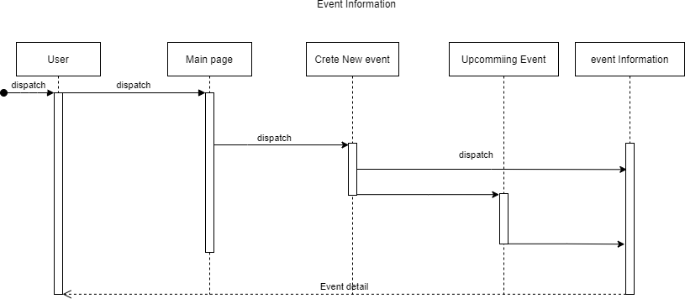

**Figure Event Information**

#### 3.1.3.4 Class Diagram

### Use Case Event Information

#### Class Identification

**Table 3 View Event Information Identification Table**

|  |  |  |
| --- | --- | --- |
| No | Design Class Name | Class Type |
| 1. | User | User |
| 2. | Main page | Main page |
| 3. | Upcoming Event | Upcoming Event |
| 4. | Event Information | Event Information |

#### Sequence Diagram

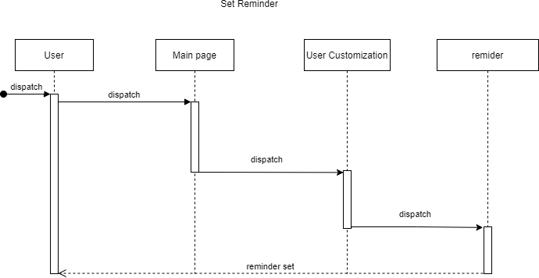Picture 4 Sequence Diagram Set Remainder.

**Figure Set Remainder**

#### Class Diagram

### Use Case Reminder

#### Class Identification

**Table 4 Reminder set Class Identification Table**

|  |  |  |
| --- | --- | --- |
| No | Design Class Name | Class Type |
| 1. | User | User |
| 2. | Main page | Main page |
| 3. | User Customization | Upcoming Event |
| 4. | Reminder | Reminder |

### Use Case Change Theme

#### Class Identification

**Table 3 Add Order Class Identification Table**

|  |  |  |
| --- | --- | --- |
| No | Design Class Name | Class Type |
| 1. | Use | User |
| 2. | Main page | Main page |
| 3. | User Customization | User Customization |
| 4. | Change Theme | Change Theme |

#### Sequence Diagram

Picture 4 Sequence Diagram Ringtone Alarm.

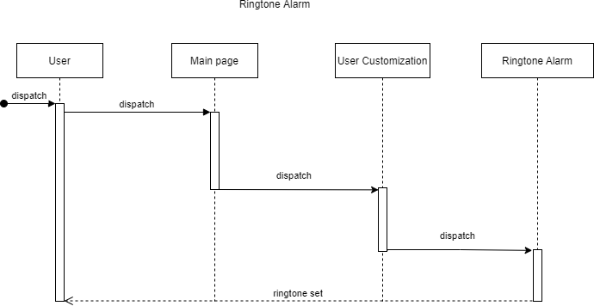

#### Class Diagram

### Use Case Add Courier

#### Class Identification

**Table 4 Ringtone Alarm Class Identification Table**

|  |  |  |
| --- | --- | --- |
| No | Design Class Name | Class Type |
| 1. | User | User |
| 2. | Main page | Main page |
| 3. | User Customization | User Customization |
| 4. | Ringtone Alarm | Ringtone Alarm |

#### Sequence Diagram

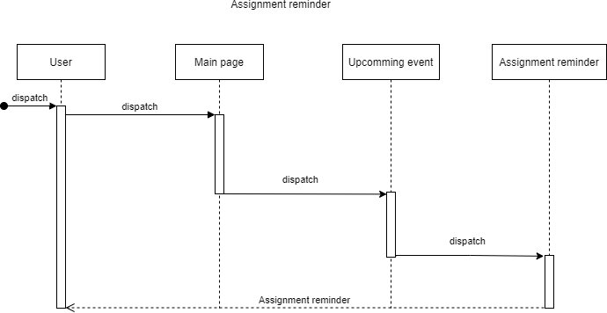Picture 4 Sequence Diagram Assignment Reminder.

#### Class Diagram

### Use Case Assignment Reminder

#### Class Identification

**Table 4 Edit Courier Data Class Identification Table**

|  |  |  |
| --- | --- | --- |
| No | Design Class Name | Class Type |
| 1. | User | User |
| 2. | Main page | Main page |
| 3. | Upcoming Event | Upcoming Event |
| 4. | Assgnment Reminder | Assignment Reminder |

#### Design Detailed Classes

**Tabel Design Detailed Classes**

|  |  |  |
| --- | --- | --- |
| No | Design Class | Name Related Analysis |
| 1. | main | main |
| 2. | Login | Login |
| 3. | Create New Event | Create new Event |
| 4. | Event Information | Event Information |
| 5. | Upcoming Event | Upcoming Event |
| 6. | User Customization | User Customization |
| 7. | Assignment Reminder | Assignment Reminder |

#### Event Information

This section is filled with a list of operations and Create attributes for each class.

Name of Class : main

### Operations and Create attributes

|  |  |  |
| --- | --- | --- |
| ***Operation Name*** | ***Visibility (private, public)*** | ***Description*** |
| *Filled with operation signature* |  |  |
|  |  |  |
|  |  |  |
| ***Attribute Name*** | ***Visibility (private, public)*** | ***Type*** |

|  |  |  |
| --- | --- | --- |
| **Study Program S1 Informatics** | **DPPL-XXX** | **Page 17 of 19** |
| This document template and the information it contains are the property of the Tel-U Informatics Study Program and are confidential. Reproduction of this document is prohibited without the knowledge Study of the Tel-U Informatics | | |

|  |  |  |
| --- | --- | --- |
| *Filled with attribute name* |  | *Write the type according to what is known in the programming language used* |
|  |  |  |
|  |  |  |

* + 1. **Class**

This section we filled with the over all class for prosses

* 1. **Diagram Overall Class**

This section is filled with the overall class diagram

## Algorithm/Query

This section is filled to describe the algorithms for the methods of

Class that is considered important. Skeleton code implementation is also possible

conducted for classes defined in a particular programming language.

## Algorithm for Admin, Customer, and Courier

Class Name : Login

Operation Name : Login

Algorithm : Algo-001

Query :

## Algorithm for Order

Class Name :

Operation Name :

Algorithm : Algo-002

Query :

## Algorithm for Admin and Order

Class Name :

Operation Name :

Algorithm : Algo-003

Query :

## Interface Design

Interface : Login page

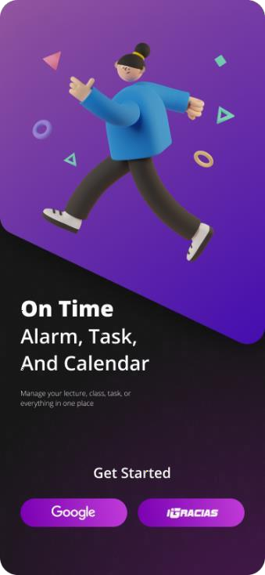

**Table Navigation Table**

|  |  |  |  |
| --- | --- | --- | --- |
| **Object_id** | **Type** | **Name** | **Explanation** |
| Banner1 | Panel Button | OK | If clicked, User will be log in using gmail |
| Banner 2 | Panel Button | OK | If clicked, User will be login igracias |

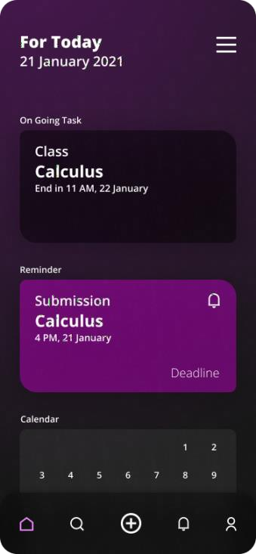Interface : Menu Page

**Table Navigation Table**

|  |  |  |  |
| --- | --- | --- | --- |
| **Object_id** | **Type** | **Name** | **Explanation** |
| Button3 | Button | OK | If clicked, User will be directed to a assignment submission |
| Button2 | Button | OK | If clicked, User can see other option on the side bar |

Interface : Detail List Page

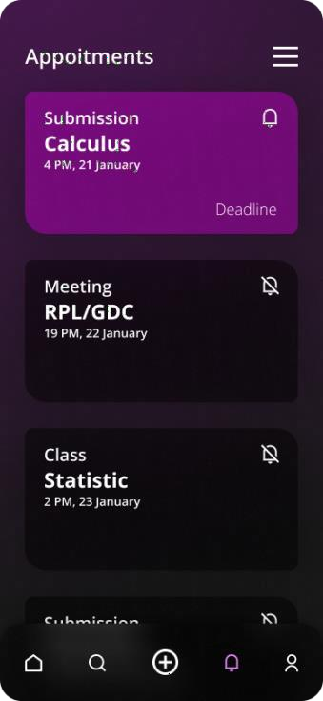

**Table Navigation Table**

|  |  |  |  |
| --- | --- | --- | --- |
| **Object_id** | **Type** | **Name** | **Explanation** |
| Button3 | Button | OK | If clicked, User will be directed to a assignment |
| Button2 | Button | OK | If clicked, User can see other option on the side bar |

## Design of Class Persistence Representation

This section is filled with datebase schema design and its traceability to the entity class(Relationship Scheme Development)

# Usability Matrix

Usability Matrix Table

|  |  |  |  |
| --- | --- | --- | --- |
| Number | Requirement Code | Function | Description |
| 1. | FR-01 |  |  |
| 2. | FR-02 |  |  |
| 3. | FR-03 |  |  |
| 4. | FR-04 |  |  |
| 5. | FR-05 |  |  |
| 6. | FR-06 |  |  |
| 7. | FR-07 |  |  |
| 8. | FR-08 |  |  |
| 9. | FR-09 |  |  |
| 10. | FR-10 |  |  |

# Testing

Practicum Assistant Code: